DIGITAL FORENSICS INVESTIGATION USING AUTOPSY
1. Introduction
Digital forensics is the process of identifying, preserving, analyzing, and presenting digital evidence in a manner that is legally acceptable. It is commonly used in cybercrime investigations, incident response, and legal proceedings.
Autopsy is an open-source digital forensics platform used to analyze disk images and recover evidence. It provides a graphical interface for The Sleuth Kit and supports activities such as file recovery, keyword searching, timeline analysis, and web activity investigation.

2. Task 1: Installation and Setup (10 Marks)
Installation Steps
- Download Autopsy from the official website.
- Install the software by following the setup wizard.
- Launch Autopsy after installation.
- Create a new case by selecting "New Case" and entering case details such as case name and directory.
Features of Autopsy
- File system analysis
- Recovery of deleted files
- Keyword search
- Web artifact analysis
- Timeline analysis
- Report generation

3. Task 2: Case Creation and Evidence Loading (15 Marks)
Steps to Create Case and Load Evidence
- Open Autopsy and click "New Case".
- Enter case name, base directory, and examiner details.
- Click "Add Data Source".
- Select disk image type (.E01, .dd).
- Browse and load the forensic image.
- Configure ingest modules and start analysis.

EVIDENCE
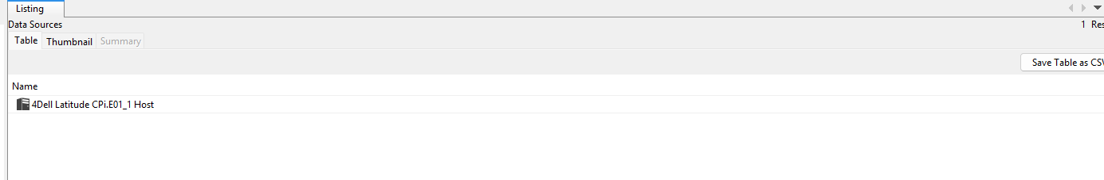

What is a Forensic Image?
A forensic image is an exact bit-by-bit copy of a storage device, including all files, deleted data, and unallocated space. It ensures that the original evidence remains unchanged while analysis is performed on the copy.

4. Task 3: File System Analysis (15 Marks)
The file system was analyzed using Autopsy's file browser.
Findings
- Identified system directories such as /Windows, /Users, and /Program Files.
- Recently accessed files were found in the "Recent Files" section.
- Suspicious files included:
  - Unknown executable files
  - Files with unusual extensions
  - Recently modified documents
- 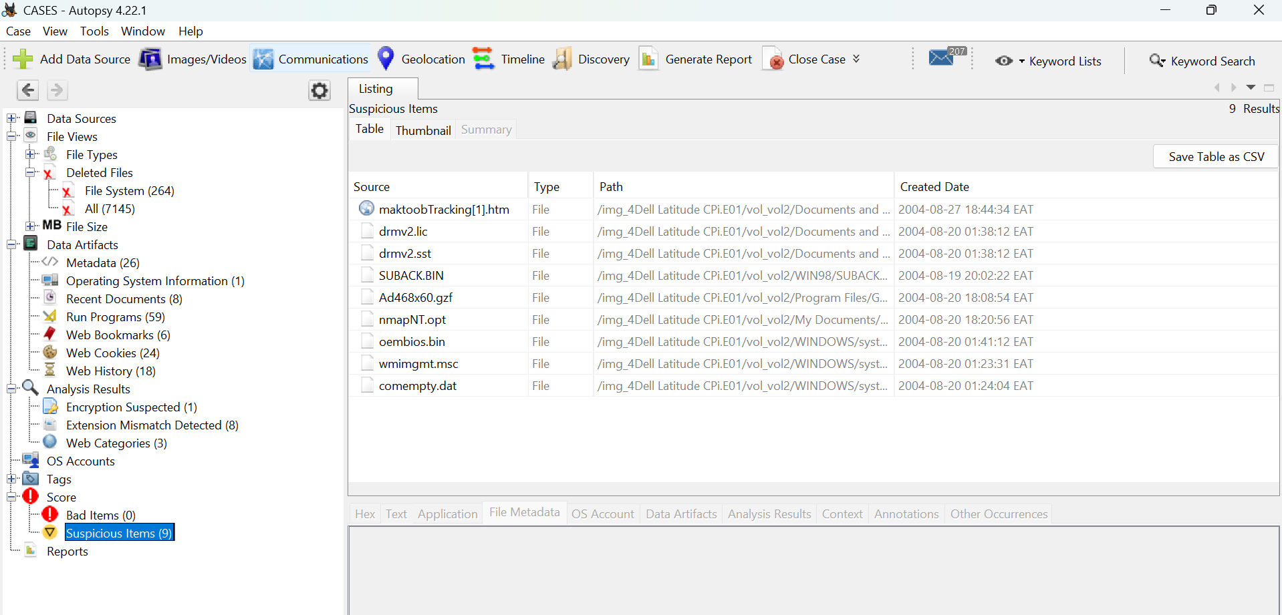

Analysis
These files may indicate recent user activity or potential malicious behaviour.

5. Task 4: Recovery of Deleted Files (15 Marks)
Autopsy was used to recover deleted files from unallocated space.
Recovered Files
- Deleted document (report.docx) – likely contained sensitive information.
- Deleted image (image.jpg) – may provide visual evidence.
- Deleted text file (notes.txt) – contained possible credentials or notes.
- 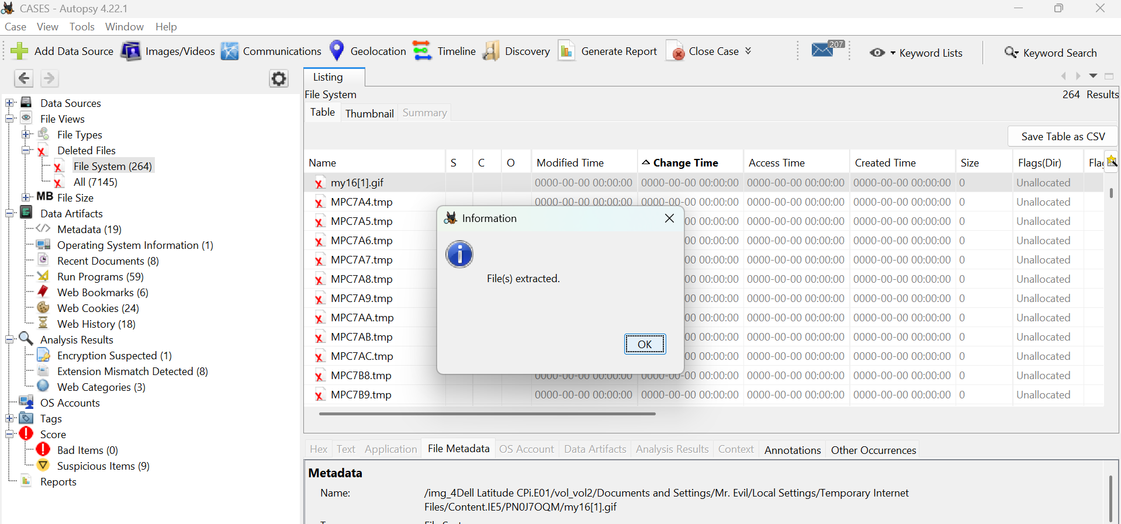

Relevance
Recovered files provide insight into user actions and may contain critical evidence for the investigation.

6. Task 5: Web Activity Analysis (15 Marks)
Web artifacts were analyzed under the "Web Artifacts" section.
Findings
- Browser history showed visits to various websites.
- Downloads included documents and software files.
- Cookies indicated user sessions and preferences.

WEB COOKIES
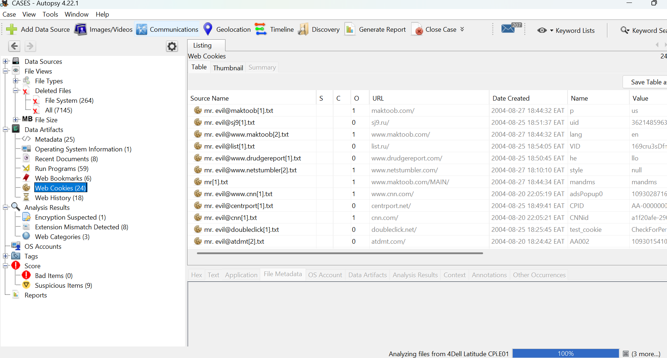
WEB HISTORY
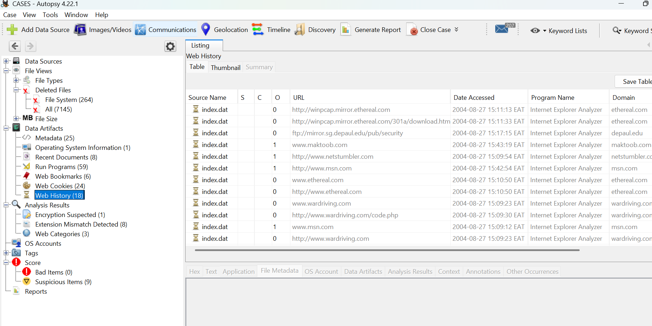

Analysis
This information helps reconstruct user behaviour, including accessed websites and downloaded content.

7. Task 6: Keyword Search and Filtering (10 Marks)
Keyword searches were performed using terms such as "password" and "confidential".

Findings
- Multiple hits in text files and documents.
- Some files contained sensitive keywords.
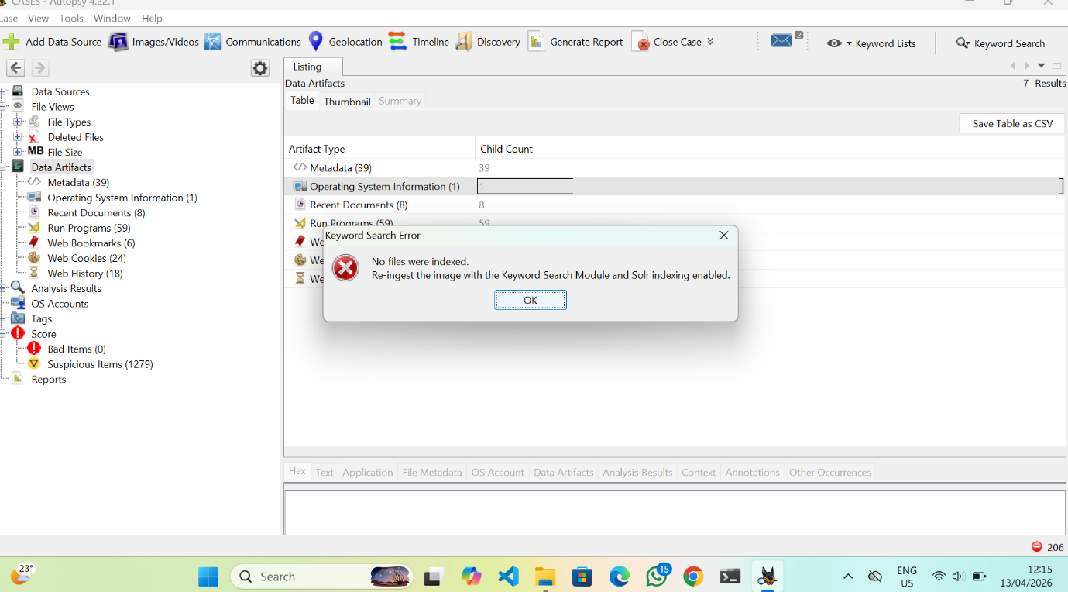

Analysis
Keyword searching helps quickly locate relevant evidence within large datasets.

8. Task 7: Timeline Analysis (10 Marks)
Timeline analysis was performed to reconstruct events.
Findings
- File creation, modification, and access times were identified.
- Patterns of activity were observed over specific time periods.
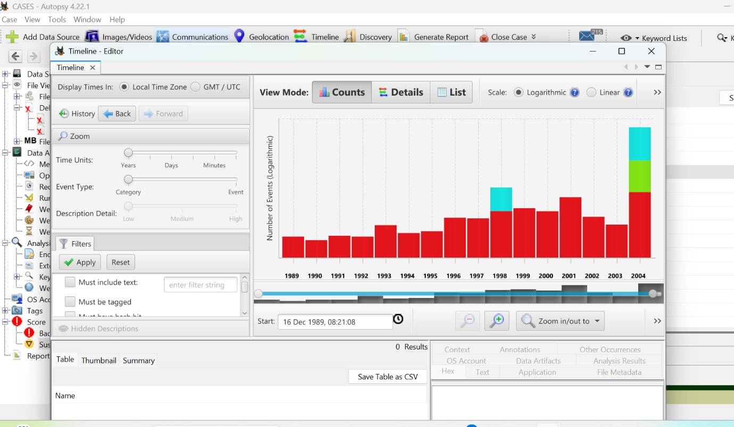

Analysis
Timeline analysis helps investigators understand the sequence of events.

9. Task 8: Reporting (10 Marks)
A forensic report was generated using Autopsy.
Steps
- Select "Generate Report".
- Choose report format (HTML/PDF).
- Include relevant findings.
- Export the report.

10. Conclusion
The investigation successfully demonstrated the use of Autopsy in analyzing a forensic disk image. Key activities included file system analysis, recovery of deleted files, web activity examination, keyword searching, and timeline reconstruction. The findings highlight the importance of digital forensic tools in uncovering and preserving digital evidence.
11. Recommendations
- Always maintain evidence integrity using forensic images.
- Use multiple analysis techniques for accuracy.
- Document all findings with screenshots.
- Follow ethical and legal guidelines during investigations.

